1. **INTRODUCTION:**

This project is aimed at developing an online application for **Buy-Sell Car Management System**. The system is an online application developed for Second Hand Car dealers. It deals with the buying/selling of used cars including make, model, prices etc. It stores the details of car owners, booking status, cars sold and bought in the database.

At present the car-shop has its working in totally a manual process. There is no interrelating entity combining all the processes carried out whether it is booking of the car or handover of the car to its owner and other day to day maintenances. All the records are kept in paper files. The biggest problem with this is that whenever any record is required all the files are to be scanned manually, which consumes a lot of valuable time and energy. Records of booking, car owner details etc. are kept in files manually and other copies of this are manually prepared for safety.

1. **END USERS OF THE SYSTEM:**

The end users of the Buy-Sell Car Management System are:

* **Admin**: The admin will verify each new user and create their account. Admin can show list of available cars to users, update the list of cars, manage sold and bought cars, manage bank related tasks, car details, booking details etc. using this module.
* **User**: User module is developed to manage the customer information is the Buy-Sell Car Management system like user login/registration, can check the car details, booking details of the customer like booked car name, make payments, check status, update customer information etc. using this module.

1. **PURPOSE OF THE PROJECT:**

The purpose of Buy-Sell Car Management System is to tackle from the following problems:

* Non-availability of data when required.
* Booking process is conducted manually, which wastes a lot of time and money.
* Duplication of data gathering and maintenance efforts.
* High level of human intervention needed and hence increasing the possibility of errors.
* No system to keep track of the booking process.
* Highly inconsistent information along with the overhead of the redundant data.

Based on the above shortcomings, it has become the necessity to design an online information system in which we can do all those mentioned things by a click of mouse on an interactive dynamic website. For this, the system has been designed in a way we needed using various languages and technologies, which are mentioned in coming chapters. Our project is meant to give people a better and trustworthy platform where they can sell and buy cars of their own choice with the help of internet and computer systems.

1. **SYSTEM DEVELOPMENT TOOLS:**

* **TECHNOLOGY USED:**

The following technology have been used for making this project:

* **Overview of ASP.NET:** (As a front end technology)

ASP.NET is a unified Web development model that includes the services necessary for you to build enterprise-class web applications with a minimum of coding. It is part of the .NET Framework. While coding ASP.NET applications, you have access to classes in the .NET Framework. You can code your applications in any language compatible with the common language runtime (CLR), including Microsoft Visual Basic and C#. These languages enable you to develop ASP.NET applications that are benefitted with the common language runtime, type safety, inheritance etc.

* **Overview of C#:** (As a supportive language for .net framework)

C# is an object-oriented programming language developed by Microsoft Corporation. C# source code and those of other .NET languages are compiled into an intermediate byte code called Microsoft Intermediate Language. C# is primarily derived from the C, C++, and Java programming languages with some features of Microsoft's Visual Basic in the mix. C# is used to develop applications for the Microsoft .NET environment. .NET offers an alternative to Java development. Microsoft's Visual Studio .NET development environment incorporates several different languages including ASP.NET, C#, C++, and J# (Microsoft Java for .NET), all of which compile to the Common Language Runtime.

* **Overview of MySQL:** (As a back end technology)

MySQL is a Relational Data Base Management System. A RDBMS in general acts as a transparent interface between physical storage and logical presentation of data. It provides set of flexible and sophisticated tools for handling information and offer many benefits.

* **Overview of Windows Operating System:**

Windows is a robust OS, which is used mainly as a server operating system. It is a multi-user, timesharing OS. In such a scenario, large number of processes exists and uses different resources. Windows has an elegant way of making the kernel space information available to the user by arranging the information in files. Also these files are sensitive to changes made to them.

* **HARDWARE REQUIREMENTS:**
* Processor: Intel Duo Core 2 Duo or above
* Hard Disk: 80 GB or more
* Color Monitor.
* RAM: 1.5 GB virtual machine
* **SOFTWARE REQUIREMENTS:**
* Front End : .Net framework (ASP.NET, C#)
* Back End : Microsoft SQL Server 2008
* Operation System : Windows 7 or Windows 8
* Internet Browser
* **INPUT REQUIREMENTS:**
* Mouse : Optical mouse with 800 dpi/laser mouse
* Keyboard : Standard 102 keys QWERTY keyboard

1. **DESIGN MODELS OF THE SYSTEM:**

The various design models used in Buy-Sell Car Management System are listed:

* **DATA FLOW DIAGRAM:**

Data flow diagrams can be used to provide a clear representation of any business function. The technique starts with an overall picture of the business and continues by analyzing each of the functional areas of interest. This analysis can be carried out in precisely the level of detail required. The technique exploits a method called top-down expansion to conduct the analysis in a targeted way.

As the name suggests, Data Flow Diagram (DFD) is an illustration that explicates the passage of information in a process. A DFD is a model for constructing and analyzing information processes. DFD illustrates the flow of information in a process depending upon the inputs and outputs. A DFD can also be referred to as a Process Model. A DFD demonstrates business or technical process with the support of the outside data saved, plus the data flowing from the process to another and the end results.

**Symbols Used are:**

* PROCESS:
* EXTERNAL ENTITY:
* DATA FLOW:

* DATA STORE:

**0-Level DFD:**

The context diagram is the most abstract data flow representation of a system. It represents the entire system as a single bubble.

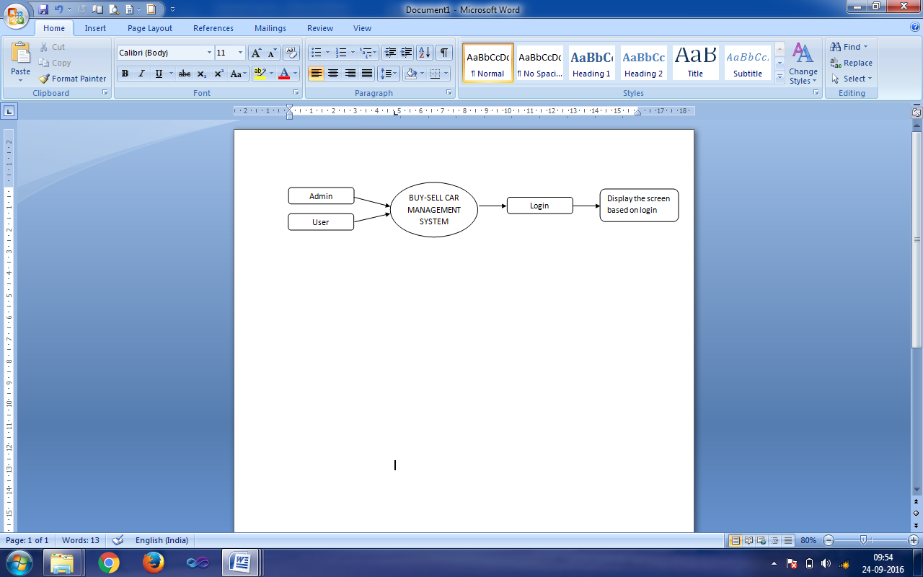

External Entity: Admin, User, Login, Display the login screen.

Process: Buy-Sell Car Management System.

**1-Level DFD:**

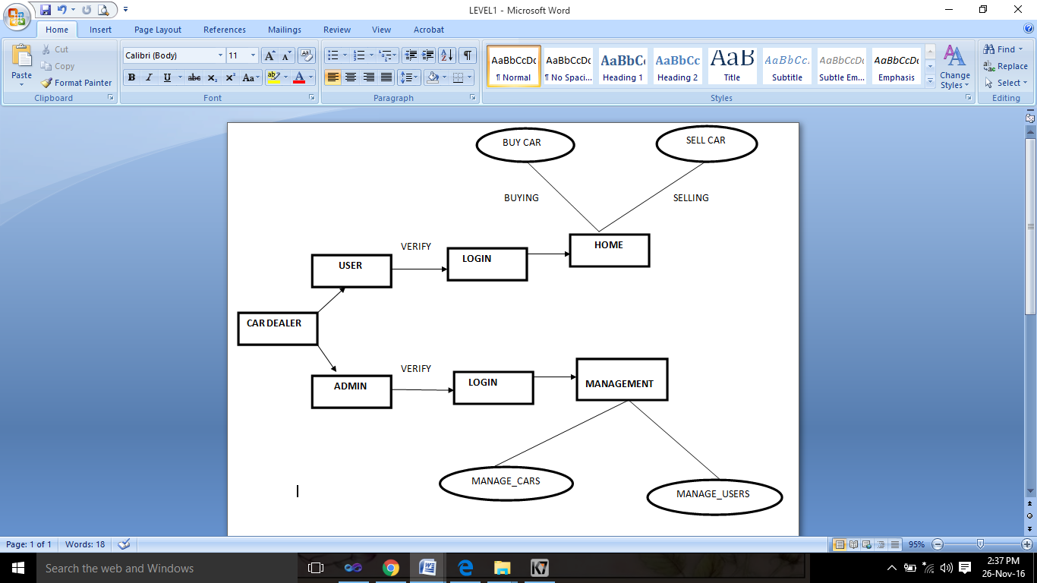

External Entity: Car Dealer, User, Admin, Login, Home, Management.

Process: Buy Car, Sell Car, Manage Cars, Manage Users.

* **ER-DIAGRAM:**

The schemas for the database application can be displayed by means of graphical notation known as Entity Relationship diagram. The ER model describes data as entities, relationships and attributes.

Entities and Attributes: An entity may be an object with a physical existence (for e.g. A particular person, car or employee) or it may be an object with a conceptual existence (for e.g. a company, a job, or a university course) Each entity has attributes i.e. the particular properties that describe it.

Relationship between Entities:

Whenever an attribute of one entity type refers to another entity type, a relationship exists.

ER Diagram for User:

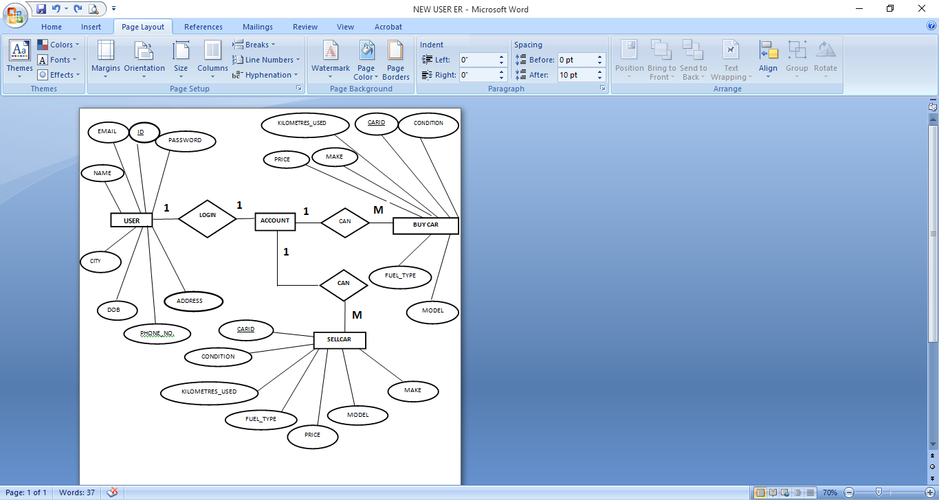

ER Diagram for Admin:

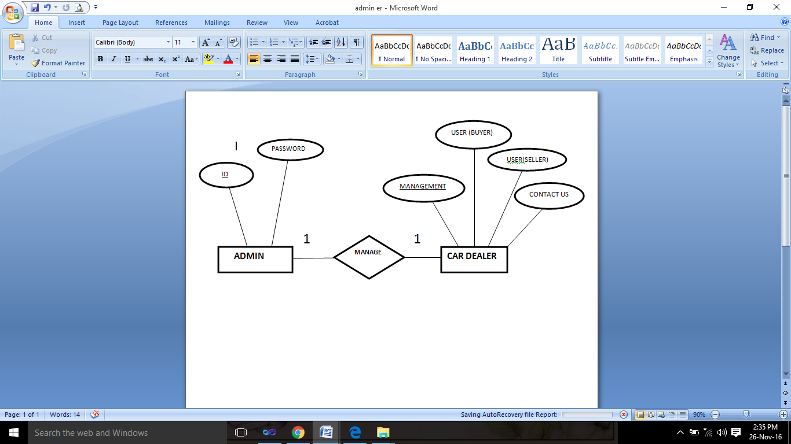

* **DATABASE DESIGN:**

Buy-Sell Car Management System database design is uploaded in this page. A database is a collection of information and is systematically stored in tables in the form of rows and columns. The table in the database has unique name that identifies its contents. The database in turn is further described in detail giving all the fields used with the data types, constraints available, primary key etc.

Database design is used to manage large bodies of information. In this database we describe all the 3 tables available in the software, which are used to store all the records.

**Data types and its description:**

Fields in database table have a data type. Some of the data types used in database table are explained below:

1. Integer: One optional sign character (+ or -) followed by at least one digit (0-9). Leading and trailing blanks are ignored. No other character is allowed.
2. Varchar: It is used to store alpha numeric characters. By default, SQL server will set the size to 50 characters large.
3. **User Data Table:**

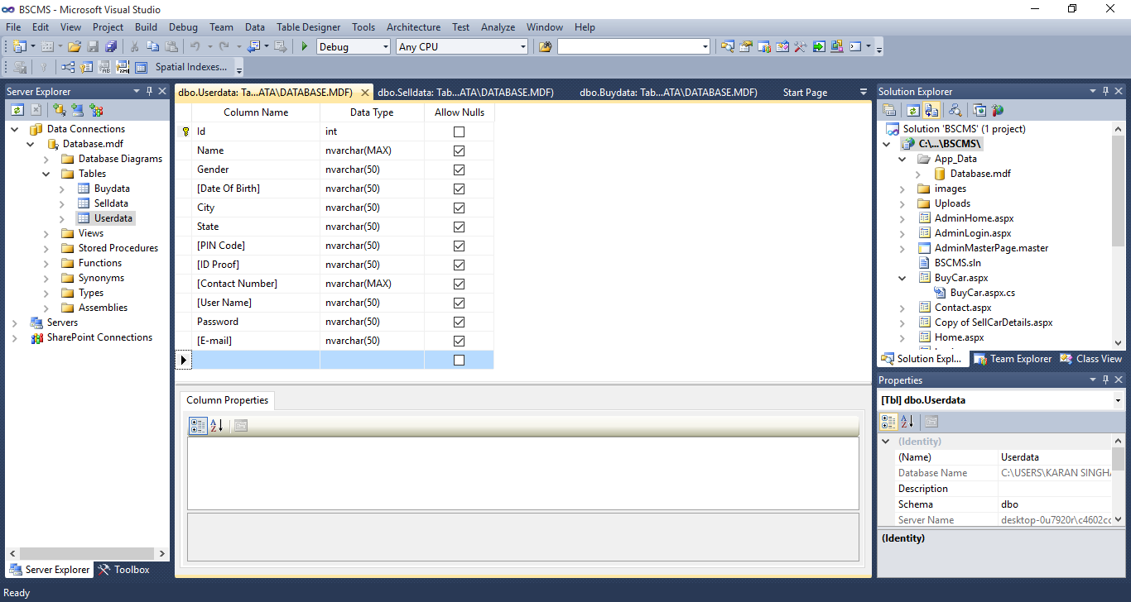

1. **Sell Car Data Table:**

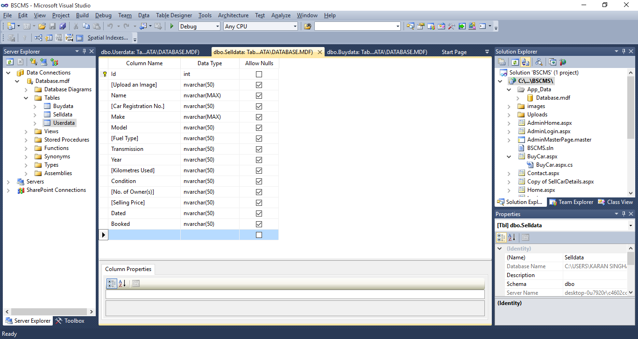

1. **Buy Car Data Table:**

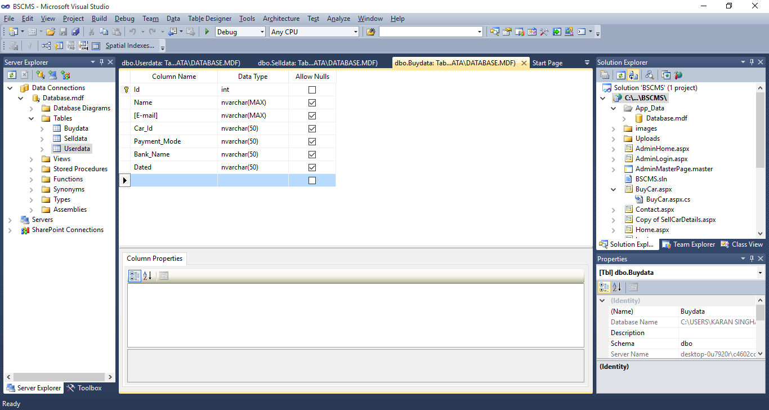

* **BASIC FLOWCHART:**

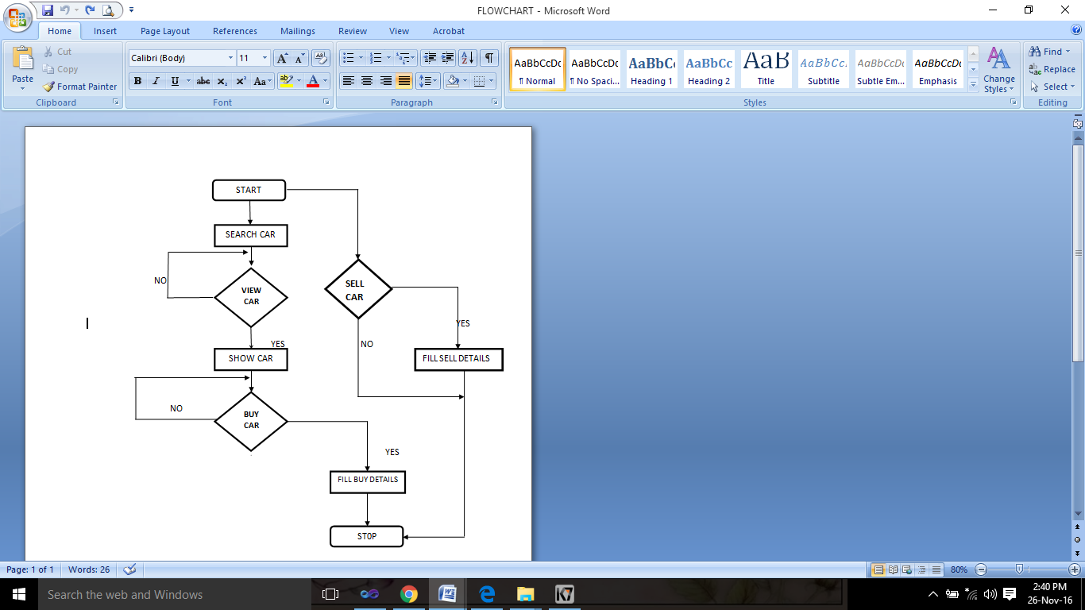

1. **COMPLETE SYSTEM MODULE DESCRIPTION:**

The project **Buy-Sell Car Management System** includes several modules. Only after the successful completion and testing of these modules, the system can be implemented. This is fully menu driven and very user friendly.

SCREENSHOTS AND CODING:

* **HOME PAGE:**

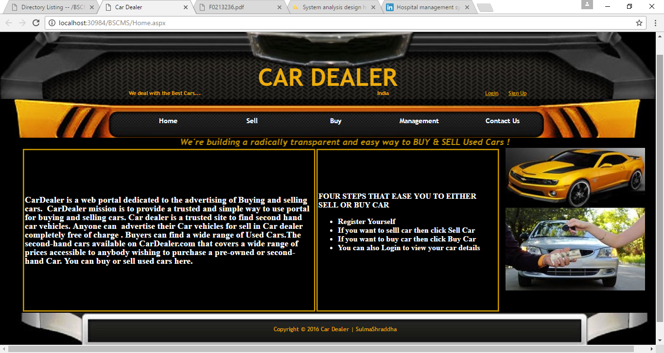

<%@ Page Title="" Language="C#" MasterPageFile="~/MasterPage.master" AutoEventWireup="true" CodeFile="Home.aspx.cs" Inherits="Home" %>

<asp:Content ID="Content1" ContentPlaceHolderID="head" Runat="Server">

<style type="text/css">

.style3

{

width: 100%;

height: 280px;

}

.style4

{

width: 594px;

height: 328px;

}

.style5

{

height: 328px;

}

</style>

</asp:Content>

<asp:Content ID="Content2" ContentPlaceHolderID="ContentPlaceHolder2" Runat="Server">

<table class="style3">

<tr>

<td class="style4" style="border: medium ridge #CC9900; background-color: black; font-family: Aharoni; font-size: large; font-style: normal; color: white;">

CarDealer is a web portal dedicated to the advertising of Buying and selling cars.&nbsp; CarDealer mission is to provide a trusted and simple way to use portal for buying and selling cars.<span class="Apple-converted-space">&nbsp;Car dealer is a trusted site to find second hand car vehicles. Anyone can&nbsp; advertise their Car vehicles for sell in

Car dealer completely free of charge&nbsp;. Buyers can find a wide range of Used Cars. The second-hand cars available on CarDealer.com that covers a wide range of prices accessible to anybody wishing to purchase a pre-owned or second-hand Car. You can buy or sell used cars here.</td>

<td class="style5" style="border: medium ridge #CC9900; background-color: black; font-family: Aharoni; font-size: medium; font-style: normal; color: white;">

FOUR STEPS THAT EASE YOU TO EITHER SELL OR BUY CAR

<asp:BulletedList ID="BulletedList1" runat="server" BorderColor="Black">

<asp:ListItem>Register Yourself</asp:ListItem>

<asp:ListItem>If you want to sell car then click Sell Car</asp:ListItem>

<asp:ListItem>If you want to buy car then click Buy Car</asp:ListItem> <asp:ListItem>You can also Login to view your car details</asp:ListItem>

</asp:BulletedList>&nbsp;</td>

</tr>

</table>

</asp:Content>

* **USER LOGIN PAGE**

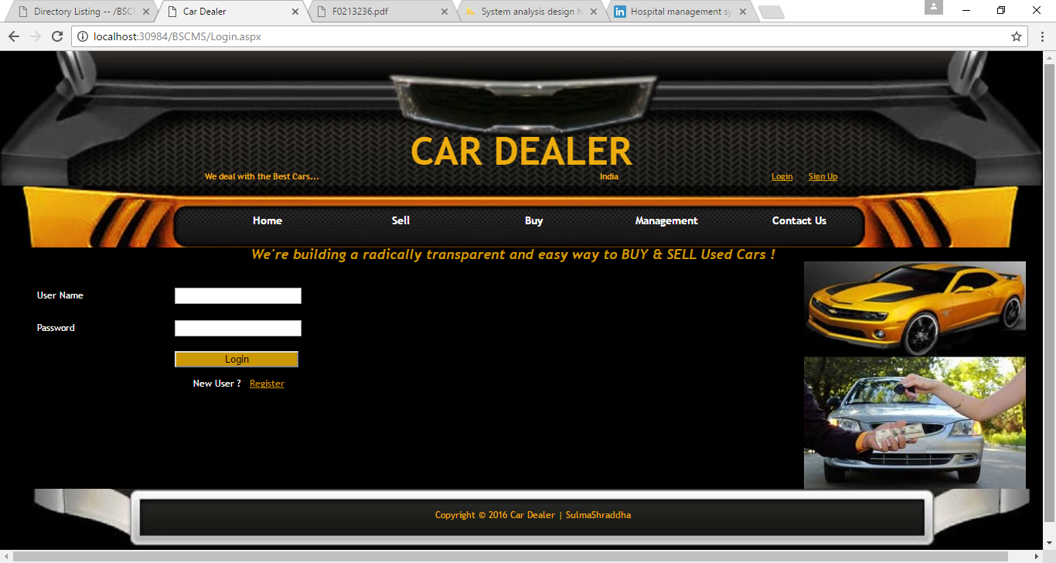

using System;

using System.Collections.Generic;

using System.Linq;

using System.Web;

using System.Web.UI;

using System.Web.UI.WebControls;

using System.Data.SqlClient;

using System.Configuration;

public partial class Login : System.Web.UI.Page

{

protected void Page_Load(object sender, EventArgs e)

{

}

protected void Button1_Click(object sender, EventArgs e)

{

SqlConnection c1 = new SqlConnection(ConfigurationManager.ConnectionStrings["RegistrationConnectionString"].ConnectionString);

c1.Open();

String checkuser = "Select count(*) from Userdata where [User Name]='" + TextBox1.Text + "'";

SqlCommand com = new SqlCommand(checkuser, c1);

int temp = Convert.ToInt32(com.ExecuteScalar().ToString());

c1.Close();

if (temp == 1)

{

c1.Open();

String checkPasswordQuery = "Select password from Userdata where [User Name]='" + TextBox1.Text + "'";

SqlCommand passcom = new SqlCommand(checkPasswordQuery, c1);

String password = passcom.ExecuteScalar().ToString().Replace(" ","");

if (password == TextBox2.Text)

{

Session["New"] = TextBox1.Text;

Response.Write("<script type=\"text/javascript\">alert(' Password is correct ! ');</script>");

Response.Redirect("Home.aspx");

}

else

{

Response.Write("<script type=\"text/javascript\">alert(' Password is incorrect ! ');</script>");

}

c1.Close();

}

else

{

Response.Write("<script type=\"text/javascript\">alert(' User Name is incorrect ! ');</script>");

}}}

* **USER REGISTRATION PAGE:**

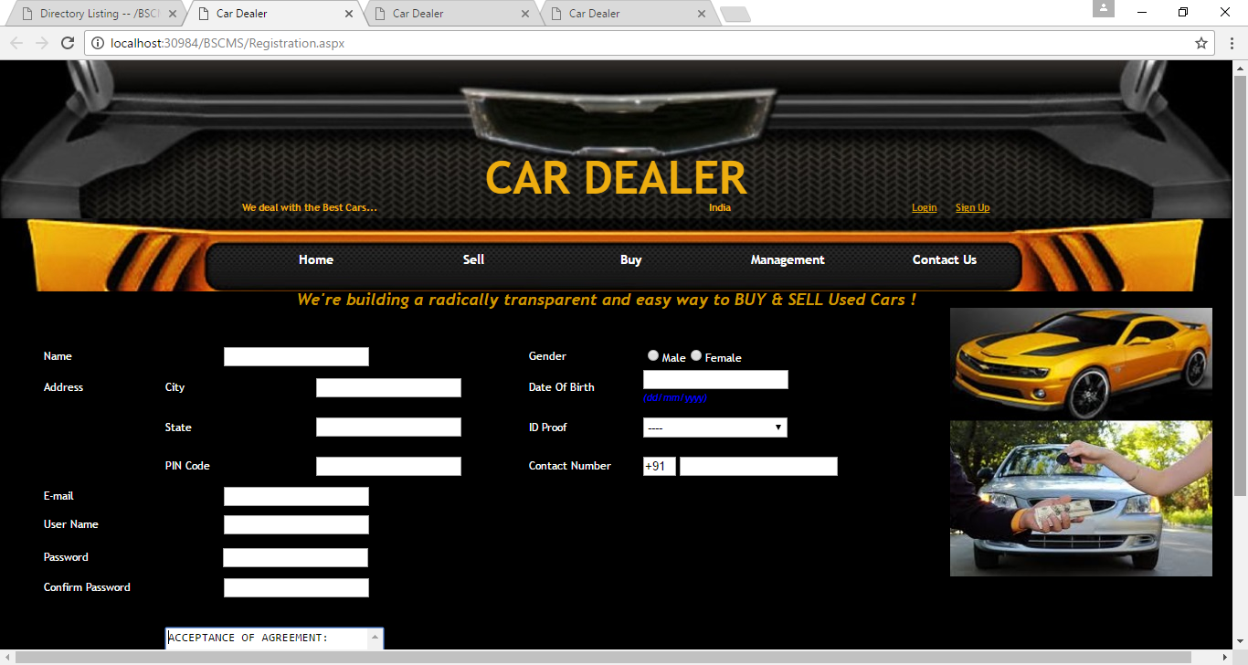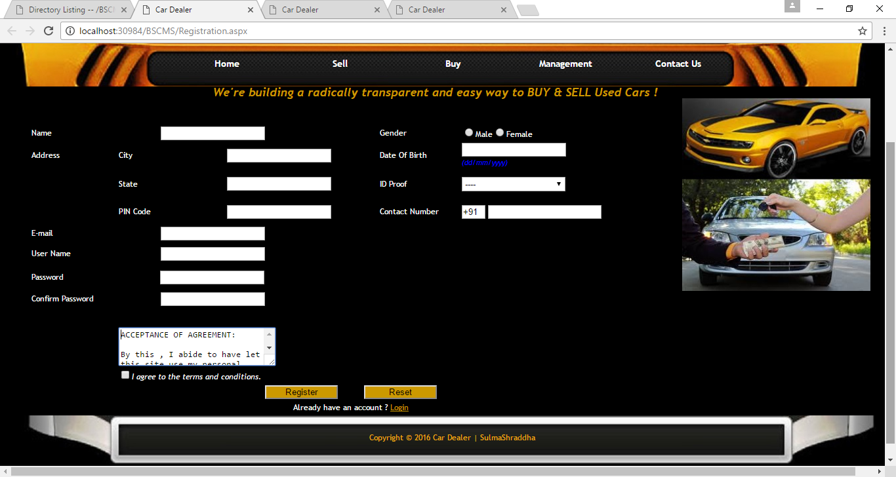

using System;

using System.Collections.Generic;

using System.Linq;

using System.Web;

using System.Web.UI;

using System.Web.UI.WebControls;

using System.Configuration;

using System.Data.SqlClient;

using System.Collections;

using System.Data;

using System.Web.Security;

using System.Web.UI.HtmlControls;

using System.Web.UI.WebControls.WebParts;

using System.Xml.Linq;

public partial class Registration1 : System.Web.UI.Page

{

protected void Page_Load(object sender, EventArgs e)

{

}

protected void Button1_Click(object sender, EventArgs e)

{

SqlConnection con = new SqlConnection(ConfigurationManager.ConnectionStrings["RegistrationConnectionString"].ConnectionString);

if (Session["new"] != null)

{

con.Open();

string ckeckuser = "Select count(*) from UserData where [User Name]='" + TBUserName.Text + "'";

SqlCommand com = new SqlCommand(ckeckuser, con);

int temp = Convert.ToInt32(com.ExecuteScalar().ToString());

if (temp != 0)

{

Response.Write("<script type=\"text/javascript\">alert(' User already exists ! ');</script>");

}

else

{

try

{

string insert = "insert into Userdata (Name,Gender,[Date Of Birth],City,State,[PIN Code],[ID Proof],[Contact Number],[E-mail],[User Name],Password) values (@Name,@Gender,@DOB,@City,@State,@Pin,@Id,@Contact,@Email,@UN,@Pass)";

SqlCommand insertcom = new SqlCommand(insert, con);

insertcom.Parameters.AddWithValue("@Name", TBName.Text);

insertcom.Parameters.AddWithValue("@Gender", RBGender.Text);

insertcom.Parameters.AddWithValue("@DOB", TBDoB.Text);

insertcom.Parameters.AddWithValue("@City", TBCity.Text);

insertcom.Parameters.AddWithValue("@State", TBState.Text);

insertcom.Parameters.AddWithValue("@Pin", TBPIN.Text);

insertcom.Parameters.AddWithValue("@Id", DDId.Text);

insertcom.Parameters.AddWithValue("@Contact", TBContactNo.Text);

insertcom.Parameters.AddWithValue("@Email", TBEmail.Text);

insertcom.Parameters.AddWithValue("@UN", TBUserName.Text);

insertcom.Parameters.AddWithValue("@Pass", TextBoxP.Text);

insertcom.ExecuteNonQuery();

con.Close();

Response.Write("<script type=\"text/javascript\">alert(' You are now Registered ! ');</script>");

Response.Redirect("Login.aspx");

}

catch (Exception ex)

{

Response.Write("Error:" + ex.ToString());

}

}

}

}

protected void CustomValidator1_ServerValidate(object source, ServerValidateEventArgs args)

{

args.IsValid=CheckBox1.Checked;

}

protected void Button2_Click(object sender, EventArgs e)

{

Response.Redirect("Registration.aspx");

}

}

* **SELL CAR PAGE:**

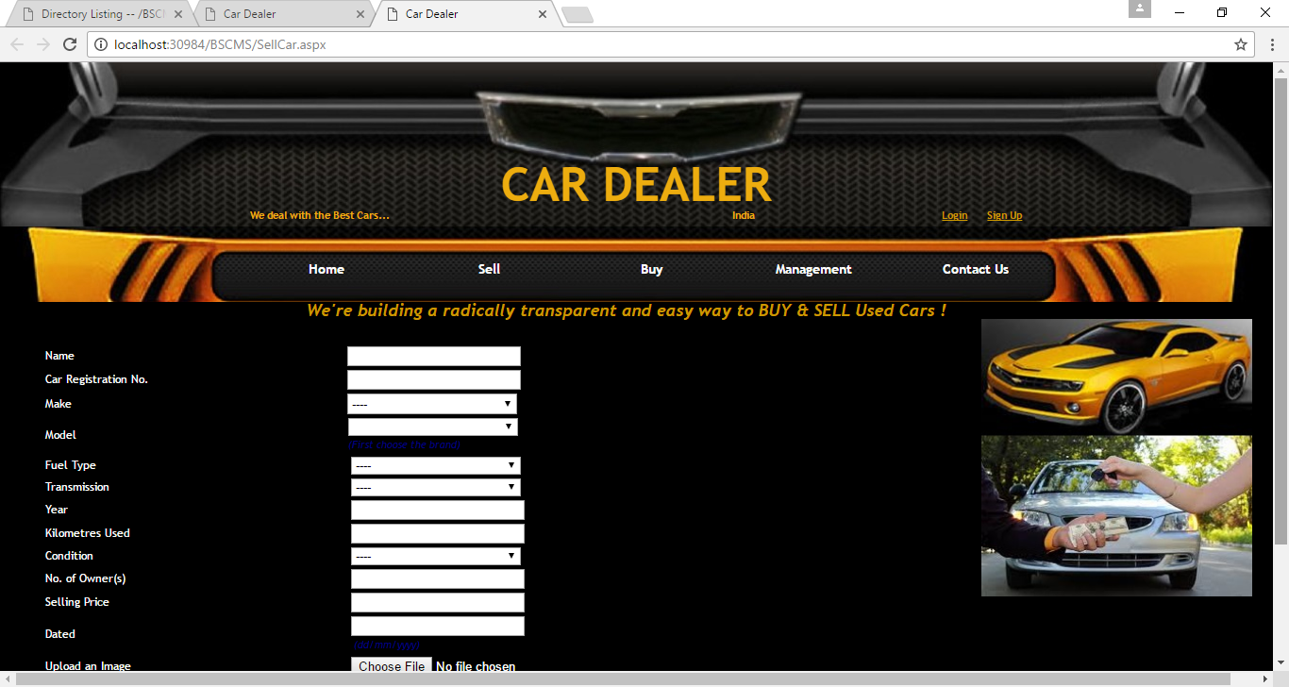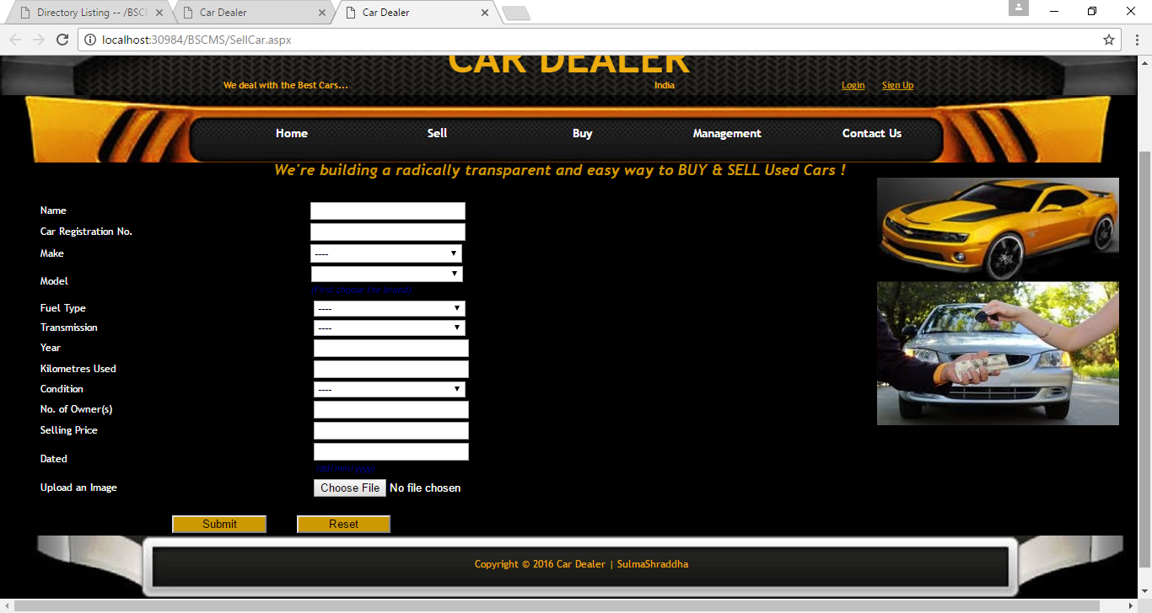

using System;

using System.Collections;

using System.Data;

using System.Collections.Generic;

using System.Linq;

using System.Web;

using System.Web.UI;

using System.Web.Security;

using System.Web.UI.WebControls;

using System.Web.UI.HtmlControls;

using System.Data.SqlClient;

using System.Web.UI.WebControls.WebParts;

using System.Xml.Linq;

using System.Configuration;

using System.IO;

public partial class SellCar : System.Web.UI.Page

{

public SqlConnection con = new SqlConnection(ConfigurationManager.ConnectionStrings["RegistrationConnectionString"].ConnectionString);

protected void Page_Load(object sender, EventArgs e)

{

}

protected void Submit_Click(object sender, EventArgs e)

{

if (Session["new"] != null)

{

con.Open();

string checkcar = "Select count(*) from Selldata where [Car Registration No.]='" + TCarRegis.Text + "'";

SqlCommand com2 = new SqlCommand(checkcar,con);

int temp2 = Convert.ToInt32(com2.ExecuteScalar().ToString());

if (temp2 != 0)

{

Response.Write("<script type=\"text/javascript\">alert(' Car is already registered ! ');</script>");

}

else

{

try

{

string str = FileUpload1.FileName;

FileUpload1.PostedFile.SaveAs(Server.MapPath(".") + "//Uploads//" + str);

string path = "~//Uploads//" + str.ToString();

string insert = "insert into Selldata(Name,[Car Registration No.],Make,Model,[Fuel Type],Transmission,Year,[Kilometres Used],Condition,[No. of Owner(s)],[Selling Price],Dated,[Upload an Image])values(@Name,@CRN,@Make,@Model,@Fuel,@Transmission,@Year,@KmUsed,@Condition,@NoOfOwner,@Sell,@Date,@Upload)";

SqlCommand insertcom = new SqlCommand(insert, con);

insertcom.Parameters.AddWithValue("@Upload", path);

insertcom.Parameters.AddWithValue("@Name", TName.Text);

insertcom.Parameters.AddWithValue("@CRN", TCarRegis.Text);

insertcom.Parameters.AddWithValue("@Make", DMake.Text);

insertcom.Parameters.AddWithValue("@Model", DModel.Text);

insertcom.Parameters.AddWithValue("@Fuel", DFuel.Text);

insertcom.Parameters.AddWithValue("@Transmission", DTransission.Text);

insertcom.Parameters.AddWithValue("@Year", TYear.Text);

insertcom.Parameters.AddWithValue("@KmUsed", TKm.Text);

insertcom.Parameters.AddWithValue("@Condition", DCondition.Text);

insertcom.Parameters.AddWithValue("@NoOfOwner", TNoofOwner.Text);

insertcom.Parameters.AddWithValue("@Sell", TSelling.Text);

insertcom.Parameters.AddWithValue("@Date", TDated.Text);

insertcom.Parameters.AddWithValue("Booked", "Not Booked");

insertcom.ExecuteNonQuery();

con.Close();

Response.Write("<script type=\"text/javascript\">alert(' Your Car has been Registered ! ');</script>");

}

catch (Exception ex)

{

Response.Write("Error:" + ex.ToString());

}

}

}

else

{

Response.Write("<script type=\"text/javascript\">alert(' You need to login first ! ');</script>");

}

}

protected void DMake_SelectedIndexChanged(object sender, EventArgs e)

{

DModel.Items.Clear();

int index=DMake.SelectedIndex;

if (DMake.SelectedIndex == 0)

DModel.Enabled=false;

else

{

DModel.Enabled=true;

switch(index)

{

case 1:

{

DModel.Items.Add("----");

DModel.Items.Add("Omni");

DModel.Items.Add("Alto 800");

DModel.Items.Add("WagonR");

DModel.Items.Add("Ritz");

DModel.Items.Add("");

break;

}

case 2:

{

DModel.Items.Add("----");

DModel.Items.Add("i10");

DModel.Items.Add("120");

DModel.Items.Add("Verna");

DModel.Items.Add("Accent");

break;

}

case 3:

{

DModel.Items.Add("----");

DModel.Items.Add("Volkswagon Polo");

DModel.Items.Add("Amaze");

DModel.Items.Add("Jazz");

DModel.Items.Add("Mobilo");

break;

}

case 4:

{

DModel.Items.Add("----");

DModel.Items.Add("Tavera");

DModel.Items.Add("Optra");

DModel.Items.Add("Cruze");

DModel.Items.Add("Beat");

break;

}

case 5:

{

DModel.Items.Add("----");

DModel.Items.Add("Bolero");

DModel.Items.Add("Xylo");

DModel.Items.Add("Scorpio");

DModel.Items.Add("XUV500");

break;

}

case 6:

{

DModel.Items.Add("----");

DModel.Items.Add("Indica");

DModel.Items.Add("Indigo");

DModel.Items.Add("Nano");

DModel.Items.Add("Sumo");

break;

}

}

}

}

protected void Button1_Click(object sender, EventArgs e)

{

Response.Redirect("SellCar.aspx");

}

}

* **BUY CAR PAGE:**

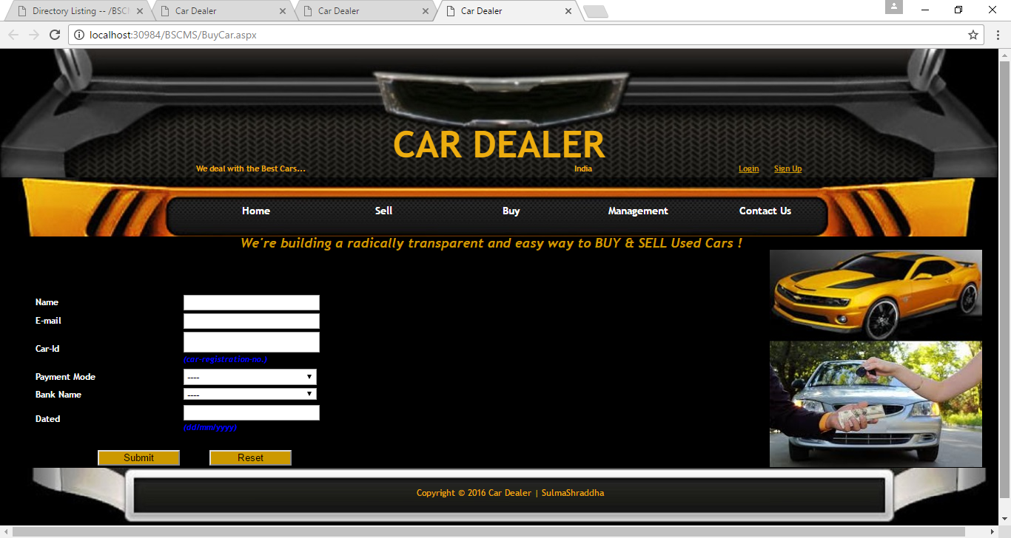

using System;

using System.Collections.Generic;

using System.Linq;

using System.Web;

using System.Web.UI;

using System.Web.UI.WebControls;

using System.Configuration;

using System.Data.SqlClient;

public partial class BuyCar : System.Web.UI.Page

{

public SqlConnection con = new SqlConnection(ConfigurationManager.ConnectionStrings["RegistrationConnectionString"].ConnectionString);

protected void Page_Load(object sender, EventArgs e)

{

}

protected void Submit_Click(object sender, EventArgs e)

{

if (Session["new"] != null)

{

con.Open();

SqlCommand com3;

string checkcar = "Select count(*) from Selldata where [Car Registration No.]='" + TBCar_Id.Text + "'";

SqlCommand com2 = new SqlCommand(checkcar, con);

int temp2 = Convert.ToInt32(com2.ExecuteScalar().ToString());

if (temp2 != 0)

{

string checkcar2 = "Select count(*) from Buydata where Car_Id='" + TBCar_Id.Text + "'";

SqlCommand com4 = new SqlCommand(checkcar2, con);

int temp3 = Convert.ToInt32(com4.ExecuteScalar().ToString());

if (temp3 != 0)

{

Response.Write("<script type=\"text/javascript\">alert(' The car is already booked ! ');</script>");

}

else

{

try

{

string insert = "insert into Buydata (Name,[E-mail],Car_Id,Payment_Mode,Bank_Name,Dated) values (@Name,@Email,@Car_Id,@Payment_Mode,@Bank_Name,@Dated)";

SqlCommand insertcom = new SqlCommand(insert, con);

insertcom.Parameters.AddWithValue("@Name", TBName.Text);

insertcom.Parameters.AddWithValue("@Email", TBEmail.Text);

insertcom.Parameters.AddWithValue("@Car_Id", TBCar_Id.Text);

insertcom.Parameters.AddWithValue("@Payment_Mode", DDPaymentMode.Text);

insertcom.Parameters.AddWithValue("@Bank_Name", DDBankName.Text);

insertcom.Parameters.AddWithValue("@Dated", TBDated.Text);

insertcom.ExecuteNonQuery();

com3 = new SqlCommand("UPDATE Selldata SET Booked='" + "Booked" + "' where [Car Registration No.]='" + TBCar_Id.Text + "'", con);

com3.ExecuteNonQuery();

con.Close();

Response.Write("<script type=\"text/javascript\">alert(' The car is booked for you ! ');</script>");

}

catch (Exception ex)

{

Response.Write("Error:" + ex.ToString());

}

}

}

else

{

Response.Write("<script type=\"text/javascript\">alert(' The car with the specified registration number does not exist ! ');</script>");

}

}

else

{

Response.Write("<script type=\"text/javascript\">alert(' You need to login first ! ');</script>");

}

}

protected void Button1_Click(object sender, EventArgs e)

{

Response.Redirect("BuyCar.aspx");

}

}

* **ADMIN LOGIN PAGE:**

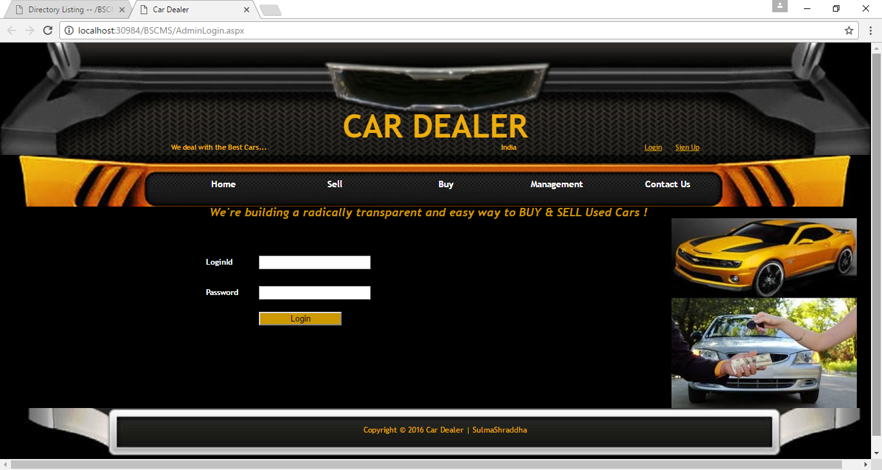

using System;

using System.Collections.Generic;

using System.Linq;

using System.Web;

using System.Web.UI;

using System.Web.UI.WebControls;

using System.Web.Configuration;

using System.Configuration;

using System.Data.SqlClient;

public partial class Admin_Login : System.Web.UI.Page

{

protected void Page_Load(object sender, EventArgs e)

{

}

protected void Button1_Click(object sender, EventArgs e)

{

if (TextBox1.Text == "admin" && TextBox2.Text == "12345")

{

Session["admin"] = TextBox1.Text;

Response.Redirect("AdminHome.aspx");

}

else

{

Response.Write("Password is not correct");

}

}

}

* **USER DETAILS PAGE:**

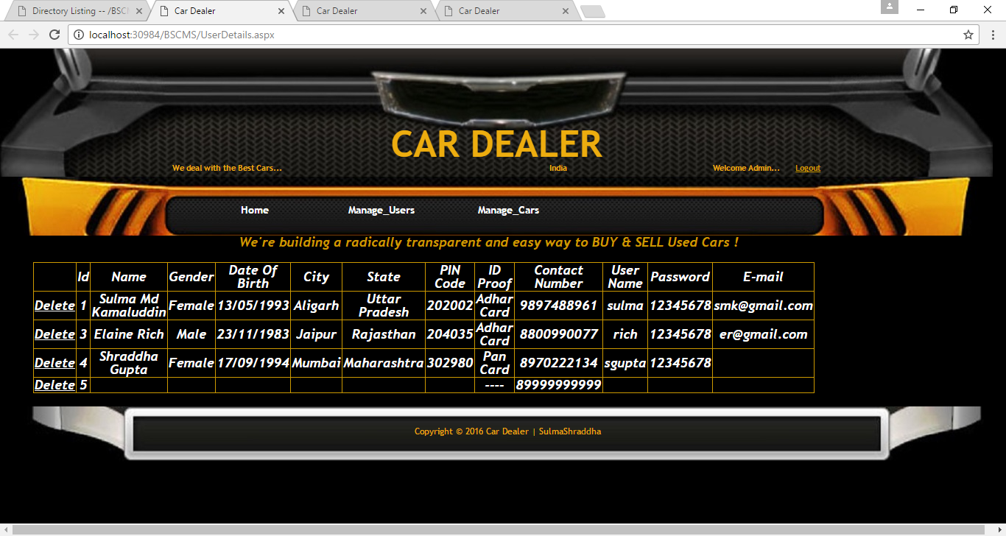

<%@ Page Title="" Language="C#" MasterPageFile="~/AdminMasterPage.master" AutoEventWireup="true" CodeFile="Copy of SellCarDetails.aspx.cs" Inherits="SellCarDetails" %>

<asp:Content ID="Content1" ContentPlaceHolderID="head" Runat="Server">

</asp:Content>

<asp:Content ID="Content2" ContentPlaceHolderID="ContentPlaceHolder2" Runat="Server">

SOLD CARS:

<br />

<br />

<asp:GridView ID="GridView1" runat="server" AutoGenerateColumns="False"

DataSourceID="SqlDataSource1" BorderColor="#CC9900" BorderStyle="Solid"

DataKeyNames="Id" ForeColor="White">

<Columns>

<asp:CommandField ShowDeleteButton="True" ShowEditButton="True" />

<asp:BoundField DataField="Id" HeaderText="Id"

SortExpression="Id" InsertVisible="False" ReadOnly="True" />

<asp:TemplateField HeaderText="Upload_an_Image">

<ItemTemplate>

<asp:Image ID="img" runat="server" ImageUrl='<%#Eval("Upload an Image")%>' Height="150" Width="250" />

</ItemTemplate></asp:TemplateField>

<asp:BoundField DataField="Name" HeaderText="Name" SortExpression="Name" />

<asp:BoundField DataField="Car Registration No."

HeaderText="Car Registration No." SortExpression="Car Registration No." />

<asp:BoundField DataField="Make" HeaderText="Make"

SortExpression="Make" />

<asp:BoundField DataField="Model" HeaderText="Model"

SortExpression="Model" />

<asp:BoundField DataField="Fuel Type" HeaderText="Fuel Type"

SortExpression="Fuel Type" />

<asp:BoundField DataField="Transmission" HeaderText="Transmission"

SortExpression="Transmission" />

<asp:BoundField DataField="Year" HeaderText="Year"

SortExpression="Year" />

<asp:BoundField DataField="Kilometres Used" HeaderText="Kilometres Used"

SortExpression="Kilometres Used" />

<asp:BoundField DataField="Condition" HeaderText="Condition"

SortExpression="Condition" />

<asp:BoundField DataField="No. of Owner(s)" HeaderText="No. of Owner(s)"

SortExpression="No. of Owner(s)" />

<asp:BoundField DataField="Selling Price" HeaderText="Selling Price"

SortExpression="Selling Price" />

<asp:BoundField DataField="Dated" HeaderText="Dated" SortExpression="Dated" />

<asp:BoundField DataField="Booked" HeaderText="Booked"

SortExpression="Booked" />

</Columns>

</asp:GridView>

<asp:SqlDataSource ID="SqlDataSource1" runat="server"

ConnectionString="<%$ ConnectionStrings:RegistrationConnectionString %>"

SelectCommand="SELECT * FROM [Selldata]"

DeleteCommand="DELETE FROM [Selldata] WHERE [Id] = @Id"

InsertCommand="INSERT INTO [Selldata] ([Upload an Image], [Name], [Car Registration No.], [Make], [Model], [Fuel Type], [Transmission], [Year], [Kilometres Used], [Condition], [No. of Owner(s)], [Selling Price], [Dated], [Booked]) VALUES (@Upload_an_Image, @Name, @column1, @Make, @Model, @Fuel_Type, @Transmission, @Year, @Kilometres_Used, @Condition, @column2, @Selling_Price, @Dated, @Booked)"

UpdateCommand="UPDATE [Selldata] SET [Upload an Image] = @Upload_an_Image, [Name] = @Name, [Car Registration No.] = @column1, [Make] = @Make, [Model] = @Model, [Fuel Type] = @Fuel_Type, [Transmission] = @Transmission, [Year] = @Year, [Kilometres Used] = @Kilometres_Used, [Condition] = @Condition, [No. of Owner(s)] = @column2, [Selling Price] = @Selling_Price, [Dated] = @Dated, [Booked] = @Booked WHERE [Id] = @Id">

<DeleteParameters>

<asp:Parameter Name="Id" Type="Int32" />

</DeleteParameters>

<InsertParameters>

<asp:Parameter Name="Upload_an_Image" Type="String" />

<asp:Parameter Name="Name" Type="String" />

<asp:Parameter Name="column1" Type="String" />

<asp:Parameter Name="Make" Type="String" />

<asp:Parameter Name="Model" Type="String" />

<asp:Parameter Name="Fuel_Type" Type="String" />

<asp:Parameter Name="Transmission" Type="String" />

<asp:Parameter Name="Year" Type="String" />

<asp:Parameter Name="Kilometres_Used" Type="String" />

<asp:Parameter Name="Condition" Type="String" />

<asp:Parameter Name="column2" Type="String" />

<asp:Parameter Name="Selling_Price" Type="String" />

<asp:Parameter Name="Dated" Type="String" />

<asp:Parameter Name="Booked" Type="String" />

</InsertParameters>

<UpdateParameters>

<asp:Parameter Name="Upload_an_Image" Type="String" />

<asp:Parameter Name="Name" Type="String" />

<asp:Parameter Name="column1" Type="String" />

<asp:Parameter Name="Make" Type="String" />

<asp:Parameter Name="Model" Type="String" />

<asp:Parameter Name="Fuel_Type" Type="String" />

<asp:Parameter Name="Transmission" Type="String" />

<asp:Parameter Name="Year" Type="String" />

<asp:Parameter Name="Kilometres_Used" Type="String" />

<asp:Parameter Name="Condition" Type="String" />

<asp:Parameter Name="column2" Type="String" />

<asp:Parameter Name="Selling_Price" Type="String" />

<asp:Parameter Name="Dated" Type="String" />

<asp:Parameter Name="Booked" Type="String" />

<asp:Parameter Name="Id" Type="Int32" />

</UpdateParameters>

</asp:SqlDataSource>

<br />

BOUGHT CARS:<br />

<br />

<asp:GridView runat="server" AutoGenerateColumns="False"

DataSourceID="SqlDataSource2" ForeColor="White" BorderColor="#CC9900"

BorderStyle="Solid" DataKeyNames="Id">

<Columns>

<asp:CommandField ShowDeleteButton="True" ShowEditButton="True" />

<asp:BoundField DataField="Id" HeaderText="Id" SortExpression="Id"

InsertVisible="False" ReadOnly="True" />

<asp:BoundField DataField="Name" HeaderText="Name"

SortExpression="Name" />

<asp:BoundField DataField="E-mail" HeaderText="E-mail"

SortExpression="E-mail" />

<asp:BoundField DataField="Car_Id" HeaderText="Car_Id"

SortExpression="Car_Id" />

<asp:BoundField DataField="Payment_Mode" HeaderText="Payment_Mode"

SortExpression="Payment_Mode" />

<asp:BoundField DataField="Bank_Name" HeaderText="Bank_Name"

SortExpression="Bank_Name" />

<asp:BoundField DataField="Dated" HeaderText="Dated" SortExpression="Dated" />

</Columns>

</asp:GridView>

<asp:SqlDataSource ID="SqlDataSource2" runat="server"

ConnectionString="<%$ ConnectionStrings:RegistrationConnectionString %>"

SelectCommand="SELECT * FROM [Buydata]"

DeleteCommand="DELETE FROM [Buydata] WHERE [Id] = @Id"

InsertCommand="INSERT INTO [Buydata] ([Name], [E-mail], [Car_Id], [Payment_Mode], [Bank_Name], [Dated]) VALUES (@Name, @column1, @Car_Id, @Payment_Mode, @Bank_Name, @Dated)"

UpdateCommand="UPDATE [Buydata] SET [Name] = @Name, [E-mail] = @column1, [Car_Id] = @Car_Id, [Payment_Mode] = @Payment_Mode, [Bank_Name] = @Bank_Name, [Dated] = @Dated WHERE [Id] = @Id">

<DeleteParameters>

<asp:Parameter Name="Id" Type="Int32" />

</DeleteParameters>

<InsertParameters>

<asp:Parameter Name="Name" Type="String" />

<asp:Parameter Name="column1" Type="String" />

<asp:Parameter Name="Car_Id" Type="String" />

<asp:Parameter Name="Payment_Mode" Type="String" />

<asp:Parameter Name="Bank_Name" Type="String" />

<asp:Parameter Name="Dated" Type="String" />

</InsertParameters>

<UpdateParameters>

<asp:Parameter Name="Name" Type="String" />

<asp:Parameter Name="column1" Type="String" />

<asp:Parameter Name="Car_Id" Type="String" />

<asp:Parameter Name="Payment_Mode" Type="String" />

<asp:Parameter Name="Bank_Name" Type="String" />

<asp:Parameter Name="Dated" Type="String" />

<asp:Parameter Name="Id" Type="Int32" />

</UpdateParameters>

</asp:SqlDataSource>

</asp:Content>

* **CAR DETAILS PAGE:**

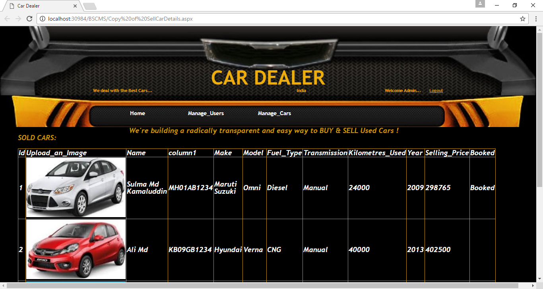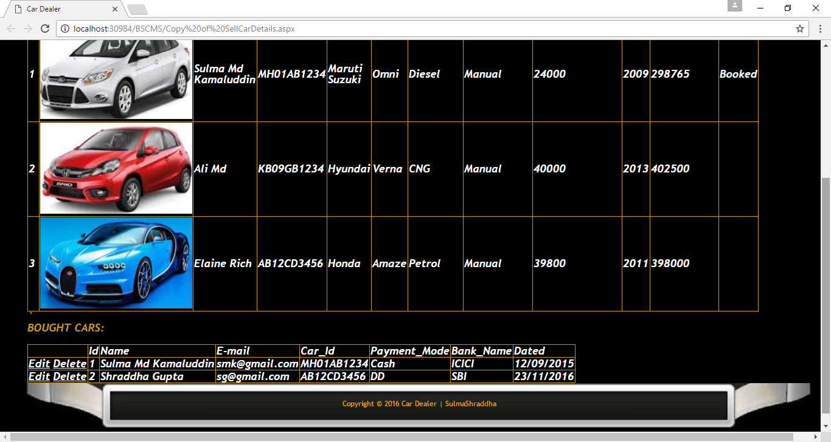

<asp:GridView ID="GridView1" runat="server" AutoGenerateColumns="False"

DataSourceID="SqlDataSource1" BorderColor="#CC9900" BorderStyle="Solid"

DataKeyNames="Id" ForeColor="White">

<Columns>

<asp:CommandField ShowDeleteButton="True" ShowEditButton="True" />

<asp:BoundField DataField="Id" HeaderText="Id"

SortExpression="Id" InsertVisible="False" ReadOnly="True" />

<asp:TemplateField HeaderText="Upload_an_Image">

<ItemTemplate>

<asp:Image ID="img" runat="server" ImageUrl='<%#Eval("Upload an Image")%>' Height="150" Width="250" />

</ItemTemplate></asp:TemplateField>

<asp:BoundField DataField="Name" HeaderText="Name" SortExpression="Name" />

<asp:BoundField DataField="Car Registration No."

HeaderText="Car Registration No." SortExpression="Car Registration No." />

<asp:BoundField DataField="Make" HeaderText="Make"

SortExpression="Make" />

<asp:BoundField DataField="Model" HeaderText="Model"

SortExpression="Model" />

<asp:BoundField DataField="Fuel Type" HeaderText="Fuel Type"

SortExpression="Fuel Type" />

<asp:BoundField DataField="Transmission" HeaderText="Transmission"

SortExpression="Transmission" />

<asp:BoundField DataField="Year" HeaderText="Year"

SortExpression="Year" />

<asp:BoundField DataField="Kilometres Used" HeaderText="Kilometres Used"

SortExpression="Kilometres Used" />

<asp:BoundField DataField="Condition" HeaderText="Condition"

SortExpression="Condition" />

<asp:BoundField DataField="No. of Owner(s)" HeaderText="No. of Owner(s)"

SortExpression="No. of Owner(s)" />

<asp:BoundField DataField="Selling Price" HeaderText="Selling Price"

SortExpression="Selling Price" />

<asp:BoundField DataField="Dated" HeaderText="Dated" SortExpression="Dated" />

<asp:BoundField DataField="Booked" HeaderText="Booked"

SortExpression="Booked" />

</Columns>

</asp:GridView>

* **ADMIN HOME PAGE:**

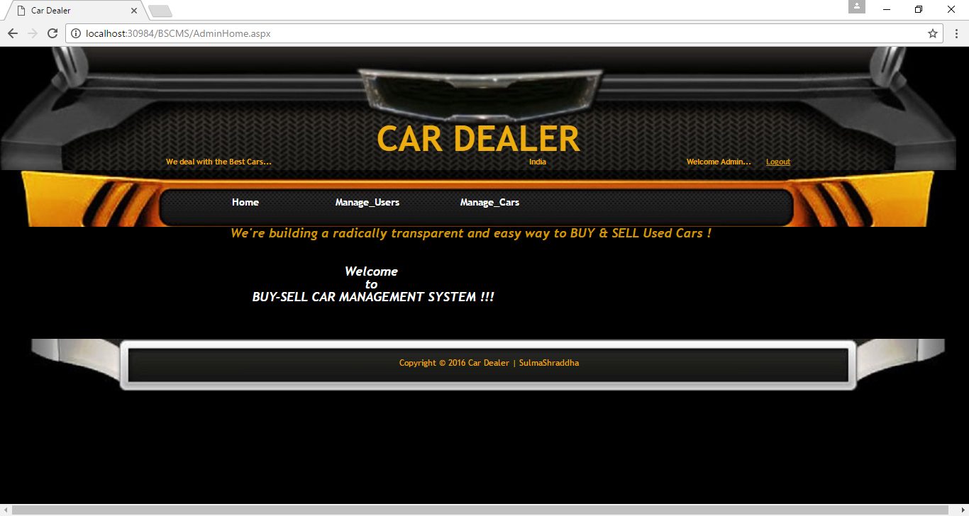

* **CONTACT US PAGE:**

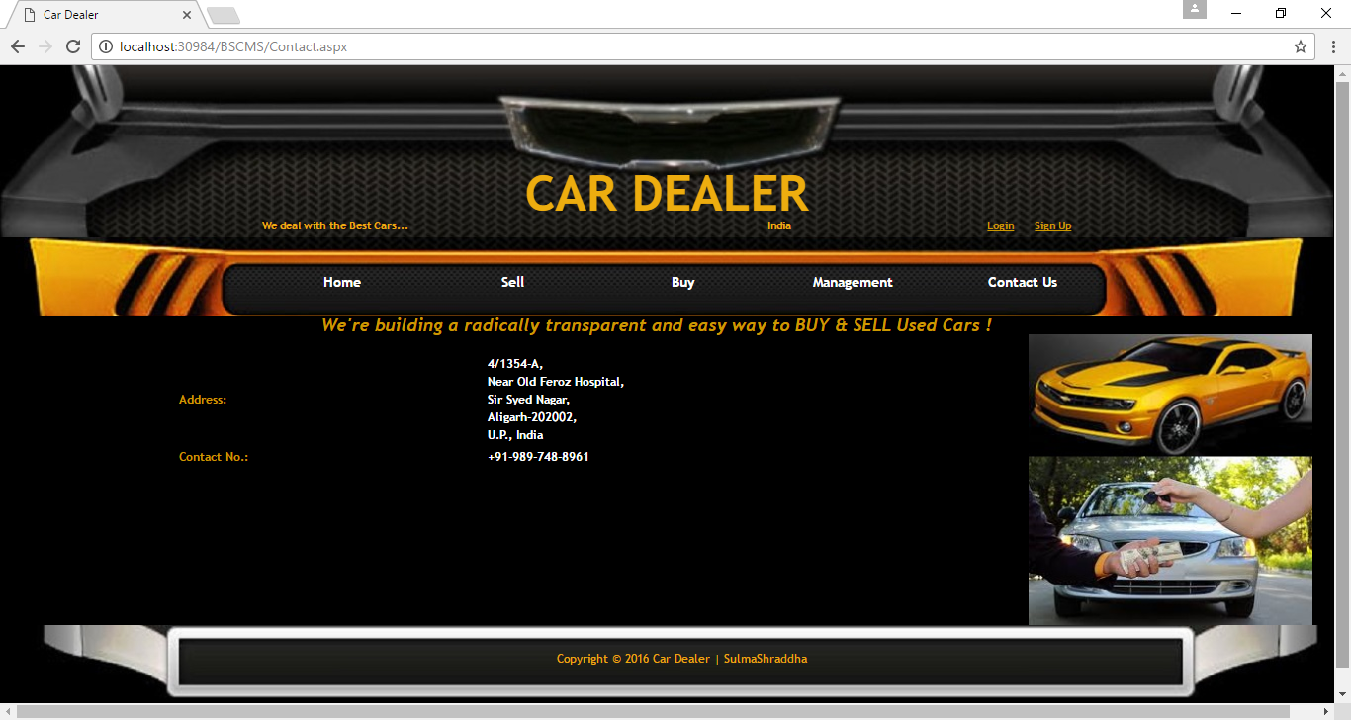

1. **MODULE-WISE TECHNICAL DOCUMENTATION:**

There are various modules in the Buy-Sell Car Management System, which are discussed below:

1. **User Login Module:** User can login to the website by entering his/ her user name and password. New user can create new account in this module.
2. **User Registration Module:** New users can register themselves to the website by entering his/her details. Registered users can login to the website by entering his/her user name and password.
3. **Sell Car Module:** Registered users can sell his/her car through the website by entering car details in this module.
4. **Search Car Module:** New user can search a car on the website in this module. Also, the registered users can view the full details of the car and can buy it.
5. **Buy Car Module:** Registered users can buy the car of choice through the website by entering the required details in this module.
6. **Administrator Login Module:** Admin can login to the website by entering his/ her user name and password in this module. Admin has full right to access this website.
7. **User Detail Module:** Only the admin can view, delete and update the user details in this module.
8. **Car Detail Module:** Only the admin can view, delete and update the bought and sold scar details in this module.
9. **REPORTS GENERATED BY THE SYSTEM:**

In the Buy-Sell Car Management System, the Search car module generates a database of the corresponding car with its image and other details, when the user enters the make and model of the car in which he/ she is interested, and clicks the Search button. The user can also view full details of the car, if he/ she is registered to the website.

SCREENSHOTS AND CODING OF **SEARCH CAR PAGE**:

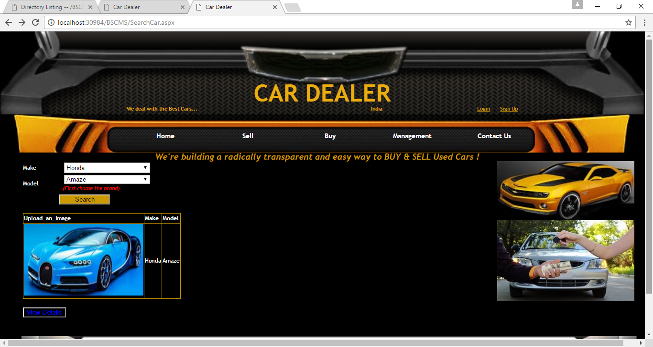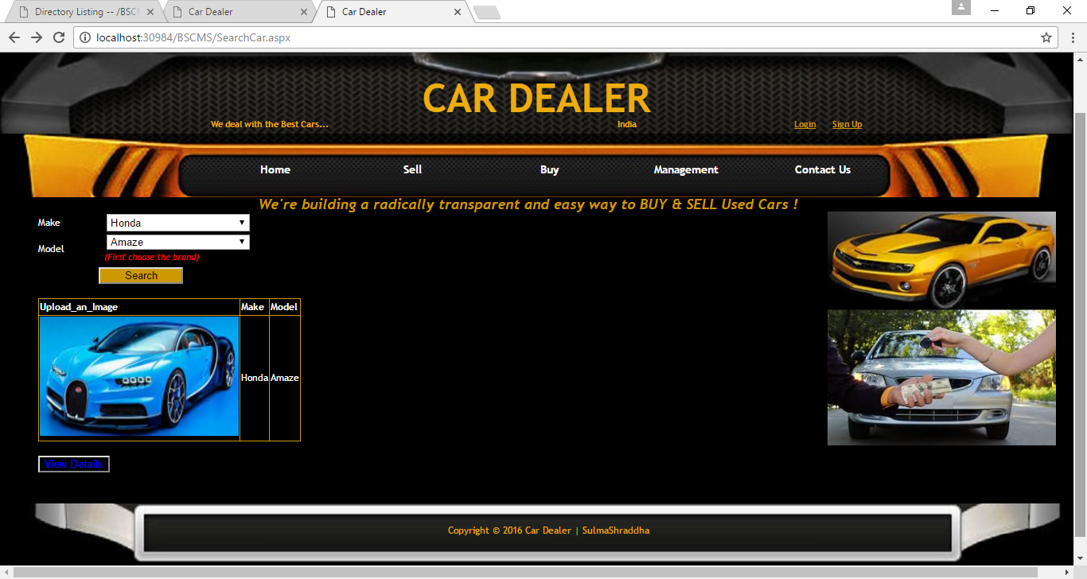 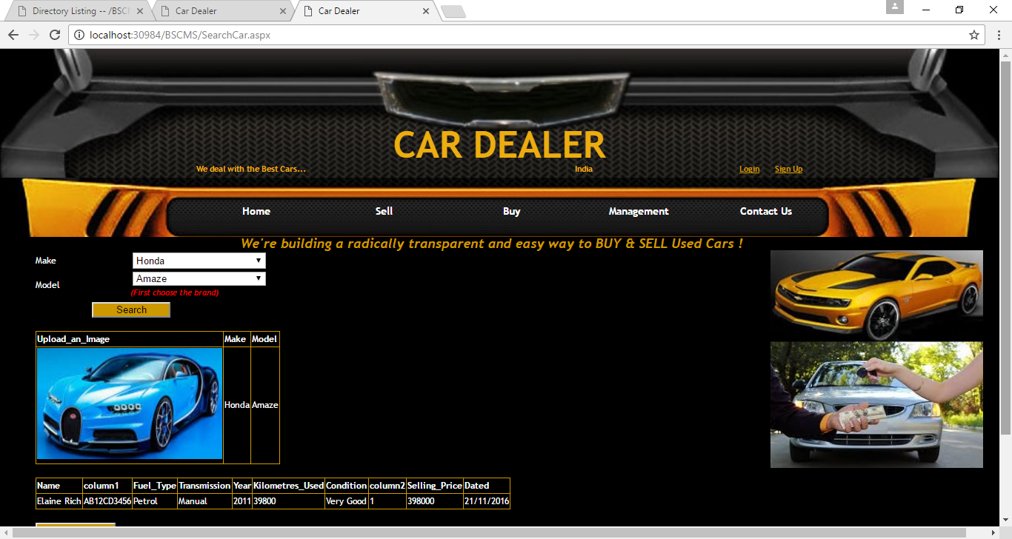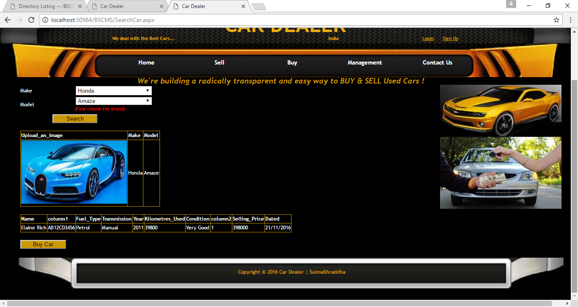

<%@ Page Title="" Language="C#" MasterPageFile="~/MasterPage.master" AutoEventWireup="true" CodeFile="SearchCar.aspx.cs" Inherits="SearchCar" %>

<asp:Content ID="Content1" ContentPlaceHolderID="head" Runat="Server">

</asp:Content>

<asp:Content ID="Content2" ContentPlaceHolderID="ContentPlaceHolder2" Runat="Server">

<table>

<tr style="border-style: none; font-size: 12px; font-weight: normal; font-style: normal; color: #FFFFFF;">

<td class="style14">

Make</td>

<td class="style12">

&nbsp;&nbsp;&nbsp;&nbsp;&nbsp;&nbsp;&nbsp;&nbsp;

<asp:DropDownList ID="DMake"

runat="server" AutoPostBack="True" onselectedindexchanged="DMake_SelectedIndexChanged"

style="height: 22px" Width="180px" >

<asp:ListItem>----</asp:ListItem>

<asp:ListItem>Maruti Suzuki</asp:ListItem>

<asp:ListItem>Hyundai</asp:ListItem>

<asp:ListItem>Honda</asp:ListItem>

<asp:ListItem Value="Chevrolet">Chevrolet</asp:ListItem>

<asp:ListItem>Mahindra</asp:ListItem>

<asp:ListItem>Tata</asp:ListItem>

</asp:DropDownList>

<asp:RequiredFieldValidator ID="RMake" runat="server"

ControlToValidate="DMake" ErrorMessage="Brand" ForeColor="Blue"

InitialValue="----" ValidationGroup="val1">*</asp:RequiredFieldValidator>

</td>

</tr>

<tr style="border-style: none; font-size: 12px; font-weight: normal; font-style: normal; color: #FFFFFF;">

<td class="style21">

Model&nbsp; </td>

<td class="style21"

style="font-style: italic; color: #FF0000; font-size: 11px">

&nbsp;&nbsp;&nbsp;&nbsp;&nbsp;&nbsp;&nbsp;&nbsp;&nbsp;&nbsp;&nbsp;

<asp:DropDownList ID="DModel" runat="server" Enabled="False" Width="180px"

>

</asp:DropDownList>

<asp:RequiredFieldValidator ID="RModel" runat="server"

ErrorMessage="Model" ForeColor="Blue" ControlToValidate="DModel"

InitialValue="----" ValidationGroup="val1">*</asp:RequiredFieldValidator>

<br />

&nbsp;&nbsp;&nbsp;&nbsp;&nbsp;&nbsp;&nbsp;&nbsp;&nbsp;&nbsp;

(First choose the brand)</td>

</tr>

<tr style="border-style: none; font-size: 12px; font-weight: normal; font-style: normal; color: #FFFFFF;">

<td class="style11" colspan="2">

&nbsp;&nbsp;&nbsp;&nbsp;&nbsp;&nbsp;&nbsp;&nbsp;&nbsp;&nbsp;&nbsp;&nbsp;&nbsp;&nbsp;&nbsp; &nbsp;&nbsp; <asp:Button ID="Submit"

runat="server" Text="Search" onclick="Submit_Click" ValidationGroup="val1"

BackColor="#CC9900" Width="106px" />

<br />

<br />

<asp:GridView ID="GridView1" runat="server" AutoGenerateColumns="False"

DataSourceID="SqlDataSource2" BorderColor="#CC9900" BorderStyle="Solid">

<Columns>

<asp:TemplateField HeaderText="Upload_an_Image">

<ItemTemplate>

<asp:Image ID="img" runat="server" ImageUrl='<%#Eval("Upload_an_Image")%>' Height="150" Width="250" />

</ItemTemplate></asp:TemplateField>

<asp:BoundField DataField="Make" HeaderText="Make" SortExpression="Make" />

<asp:BoundField DataField="Model" HeaderText="Model" SortExpression="Model" />

</Columns>

</asp:GridView>

<asp:SqlDataSource ID="SqlDataSource2" runat="server"

ConnectionString="<%$ ConnectionStrings:RegistrationConnectionString %>"

SelectCommand="SELECT [Upload an Image] AS Upload_an_Image, [Make], [Model] FROM [Selldata] WHERE ([Model] = @Model)">

<SelectParameters>

<asp:ControlParameter ControlID="DModel" Name="Model"

PropertyName="SelectedValue" Type="String" />

</SelectParameters>

</asp:SqlDataSource>

<br />

<asp:Button ID="Button1" runat="server" BackColor="Black" ForeColor="Blue"

onclick="Button1_Click" Text="View Details" ValidationGroup="val1"

Visible="true" />

<asp:GridView ID="GridView2" runat="server" AutoGenerateColumns="False"

DataSourceID="SqlDataSource3" BorderColor="#CC9900" BorderStyle="Solid">

<Columns>

<asp:BoundField DataField="Name" HeaderText="Name" SortExpression="Name" />

<asp:BoundField DataField="column1" HeaderText="column1"

SortExpression="column1" />

<asp:BoundField DataField="Fuel_Type" HeaderText="Fuel_Type"

SortExpression="Fuel_Type" />

<asp:BoundField DataField="Transmission" HeaderText="Transmission"

SortExpression="Transmission" />

<asp:BoundField DataField="Year" HeaderText="Year" SortExpression="Year" />

<asp:BoundField DataField="Kilometres_Used" HeaderText="Kilometres_Used"

SortExpression="Kilometres_Used" />

<asp:BoundField DataField="Condition" HeaderText="Condition"

SortExpression="Condition" />

<asp:BoundField DataField="column2" HeaderText="column2"

SortExpression="column2" />

<asp:BoundField DataField="Selling_Price" HeaderText="Selling_Price"

SortExpression="Selling_Price" />

<asp:BoundField DataField="Dated" HeaderText="Dated" SortExpression="Dated" />

</Columns>

</asp:GridView>

<asp:SqlDataSource ID="SqlDataSource3" runat="server"

ConnectionString="<%$ ConnectionStrings:RegistrationConnectionString %>"

SelectCommand="SELECT [Name], [Car Registration No.] AS column1, [Fuel Type] AS Fuel_Type, [Transmission], [Year], [Kilometres Used] AS Kilometres_Used, [Condition], [No. of Owner(s)] AS column2, [Selling Price] AS Selling_Price, [Dated] FROM [Selldata] WHERE ([Model] = @Model)">

<SelectParameters>

<asp:ControlParameter ControlID="DModel" Name="Model"

PropertyName="SelectedValue" Type="String" />

</SelectParameters>

</asp:SqlDataSource>

<br />

<asp:Button ID="Button2" runat="server" onclick="Button2_Click"

Text="Buy Car" BackColor="#CC9900" style="text-align: center"

Width="108px" />

<br />

<br />

</td>

</tr>

</table>

</asp:Content>

1. **CONCLUSION:**

* **LIMITATIONS:**
* The application Buy-Sell Car Management System does not include any help with the fields.
* Calendar is not attached with the date fields.
* Search button is not available in this system.
* **FUTURE EXTENSIONS:**

There is always space for improving in any software package, however good and efficient it may be. But the important thing is that the system should be flexible enough for future modification/ alteration whenever it is required.

The Buy-Sell Car Management System for the management process can be further

developed into a separate, automated system with the following enhancements:

* A mail server can be implemented to send mails directly from the system to the inbox of the recipient. The code needed for the same is being implemented except the mail server.
* Help file can be included. The system, as of now, does not support any help facility for the users of the system.
* A help menu can be provided with a special function key and help command in the main page itself. Help can be either introduced as a separate window, a reference to a printed manual or as one or two line suggestion produced in a fixed screen location.

***REFERENCES/ BIBLIOGRAPHY:***

* **Books:**
* *The Complete reference: By Noel Jerke, Published by TataMcGraw-Hill.*
* *Fundamentals of Database Systems: By Ramez Elmasri and Shamkhant B.Navathe (PHI)*
* *Computer Science (Databases, Sql and Files): By Sumita Arora (Dhanpat Rai and Co.)*
* **Websites:**
* *YouTube: Various videos for learning ASP.NET.*
* *www.w3schools.com*
* *www.microsoft.com*
* *www.codeproject.com*
* *www.stackoverflow.com*